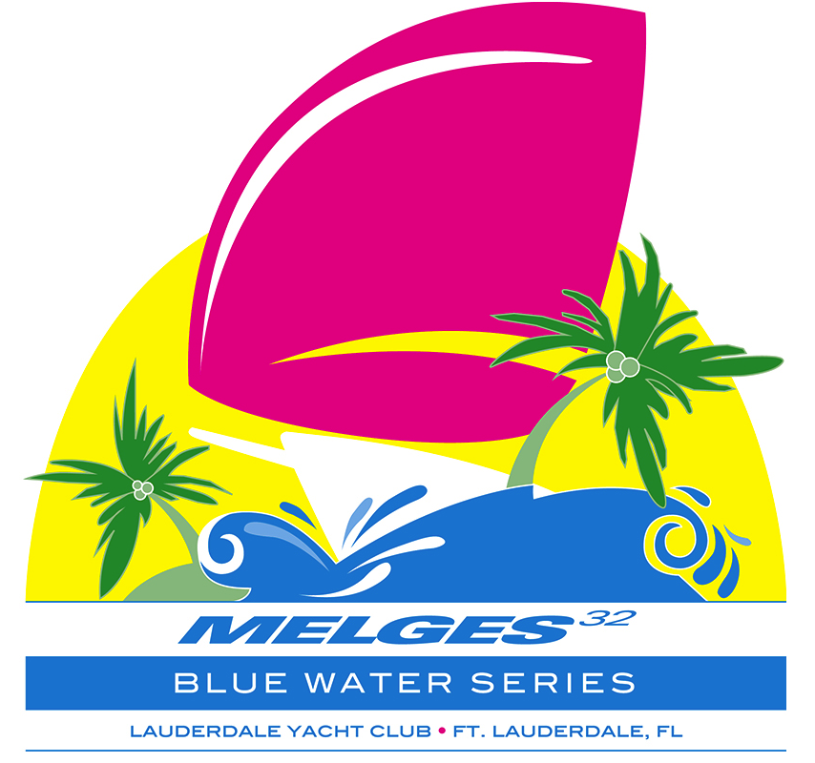

2016 Melges 32 Lauderdale Cup
Blue Water Series Event #3
April 1, 2 & 3, 2016
- Lauderdale Yacht Club

Sailing Instructions

1. RULES
1.1 This Regatta will be governed by the current Racing Rules of Sailing (RRS) 2013-2016, including US Sailing Prescriptions, the Notice of Race, the rules of the Melges 32 Class (IM32CR), these Sailing Instructions, and properly posted amendments thereto.
1.2 These Sailing Instructions, including amendments, will take precedence in the case of conflict with the Notice of Race. This modifies RRS 63.7.
1.3 The Organizing Authority (OA) is the Lauderdale Yacht Club (LYC).

2. NOTICES TO COMPETITORS
2.1 Notices to competitors will be posted on the Official Notice Board located under the LYC Pavilion on the eastern side of the property.
2.2 The Race Committee will attempt to announce its intentions for the day on VHF channel 69 at 0900 each morning of the event.
2.3 Race committee broadcasts concerning its intentions, the course to be sailed, starting times, course changes, etc. are a courtesy only. Failure of the Race Committee to make a broadcast, the timing of a broadcast, or the failure of a boat to hear a broadcast shall not be grounds for redress under rule 62.1(a).

3. CHANGES IN SAILING INSTRUCTIONS
Any change in the Sailing Instructions will be posted on the Official Notice Board before 0830 on the day it will take effect, except that any change in the schedule of races will be posted by 2000 on the day before it will take effect.

4. SIGNALS MADE ASHORE
4.1 Signals made ashore will be displayed at the flagpole at the east end of the LYC property.
4.2 When flag AP is displayed ashore, “1 minute” is replaced with “not less than 60 minutes” in the Race Signal AP, and the scheduled time of the next warning signal will be posted on the Official Notice Board when the AP is lowered. This changes Race Signal AP.
4.3 As a courtesy, signals made ashore may be reported on the Bahia Mar Notice Board.

5. SCHEDULE
5.1 Racing is scheduled each day from Friday, April 1 through Sunday April 3, 2016. Eight races are scheduled.
5.2 The scheduled time for the warning signal for the first race each day is 1100.
5.3 It is the intent of the Race Committee to run no more than three races each day. The Race Committee will signal its intent to run another race that day by displaying Flag R from the signal boat at the finish of the previous race. The Race Committee will also attempt to broadcast its intentions over VHF channel 69.

6. BOW NUMBERS and STICKERS
6.1 Bow numbers shall be displayed on both sides of the bow with the number forward in accordance with Melges 32 class guidelines.
6.2 Official Melges 32 Blue Water Series bow stickers will be distributed to teams at the Bahia Mar. These will need to be displayed just aft of the bow numbers on both sides of the hull. Replacement stickers will be available at $100 per set.

7. RACING AREA
7.1 The racing area is in the Atlantic Ocean, approximately 1.5 nautical miles south of Port Everglades Inlet and .75 miles offshore.
7.2 Competitors’ attention is drawn to the Notice Regarding Threatened Species posted on the Official Notice Board.

8. COURSES AND MARKS
8.1 The courses are shown on the attached course diagram MELGES 32 BLUE WATER SERIES COURSES.
8.2 A leeward gate (two marks) will be used. The gate will be located to windward of the starting line. Boats shall sail between the gate marks from the direction of the previous mark and round either gate mark. If one of the leeward gate marks is missing, boats shall round the one existing leeward mark to port.
8.3 A windward offset mark will be laid to port of the windward mark, approximately perpendicular to the course axis and approximately 100 to 150 yards distant. The windward offset mark is to be rounded to port.
8.4 The approximate magnetic compass bearing from the starting line to the windward mark, and the approximate distance from the leeward gate to the windward mark will be posted on the Race Committee signal boat at or prior to the warning signal.
8.5 The signal boat will display a numeral pennant corresponding to the course to be sailed at or prior to the warning signal and may also post the course number on a white board.

9. MARKS
Marks W, L-s and L-p will be orange tetrahedrons. Mark W-o and the start and finish line marks will be yellow.

10. THE START
10.1 Races will be started in accordance with racing rule RRS 26.
10.2 The Class Flag will be a flag with the Melges 32 logo.
10.3 The starting line will be between a staff displaying an orange flag on the Race Committee signal boat and the course side of the nearby yellow start mark.
10.4 The Race Committee will attempt to hail recalled boats by broadcast over VHF channel 69. Failure to receive a hail, failure for a hail to be made, or the order of hails made shall not be cause for redress.
10.5 The Race Committee will attempt to hail boats before the start which are on the course side of the starting line during the final minute of a starting sequence conducted under the "I" flag.

11. CHANGE OF COURSE AFTER THE START
11.1 To change the next leg of the course, the Race Committee will move the original mark (s) (or gate or the finishing line) to a new position.
11.2 A change of course after the start will be signaled before the leading boat has begun the leg, although the mark may not then be in position. Any mark to be rounded after rounding the new mark POSITION may be relocated to maintain the original course configuration.

12. THE FINISH
The finish line will be between a staff displaying an orange flag on the Race Committee boat and the course side of a nearby finish mark to port of the Race Committee boat (looking upwind).

13. PENALTIES
13.1 RRS 44.1 is modified by adding the following: Except for a starting mark, the Turns Penalty for a Part 2 rule broken inside the Zone shall be a Two Turns Penalty as prescribed in this rule without modification. The Turns Penalty for a Part 2 rule broken outside the Zone shall be One Turn, including one tack and one gybe. This changes RRS 44.1.
13.2 If a breach of Class Rules is found, penalties shall be at the discretion of the jury, in consultation with a non-competing Class Representative.

14. TIME LIMIT
14.1 Any race in which no yacht rounds the first windward mark within 25 minutes or finishes within 90 minutes of the start will be abandoned.
14.2 If a yacht finishes within the 90 minute limit, the time limit for all other yachts will be 15 minutes after the finish of the first yacht. Yachts not finishing within the time limit will be scored DNF without a hearing. This changes RRS 35.

15. PROTESTS AND REQUESTS FOR REDRESS
15.1 Protest forms are available at the jury desk near the Official Notice Board at the LYC Pavilion. Protests shall be delivered there within the Protest Time Limit.
15.2 The Protest Time Limit is 90 minutes from the time the Race Committee signal boat docks at LYC on Friday and Saturday, and 60 minutes from that time on Sunday. The Protest Time Limit will be posted on the Official Notice Board as soon as possible.
15.3 Protest Notices will be posted on the Official Notice Board as soon as possible after they are delivered to the jury desk to inform competitors where and when there is a hearing to which they are party. Protest hearings will be scheduled to start as soon as possible after the notices are posted. The jury will attempt to hear protests in the order of receipt. Representatives of boats who are parties to hearings and their witnesses shall remain on call in the vicinity of the Official Notice Board at LYC.
15.4 Although the Committee will make every effort to post the Protest Time Limit and Protest Notices on the Bahia Mar Notice Board, it is each boat’s responsibility to check the Official Notice Board at LYC by the end of the protest filing time to see if she is cited in a protest. Failure of any party to appear when called for a hearing will be considered by the jury as grounds for proceeding under rule 63.3(b).
15.5 Only the Race Committee may initiate a protest for a violation of Sailing Instructions 6, 17, & 20. This modifies RRS 60.1(a).

16. SCORING
16.1 The Low Point System of RRS Appendix 'A', as modified below, will apply.
16.2 Three races are required to be completed to constitute a series.
16.3 When fewer than six races have been completed, a boat's series score will be the total of her race scores. When six or more races have been completed, a boat's series score will be the total of her race scores excluding her worst score.

17. SAFETY
17.1 All yachts must carry minimum equipment as required by the U.S. Coast Guard and the Melges 32 Class Rules.
17.2 RRS 82 will not apply.
17.3 Florida law requires that vessels underway maintain a 300 foot clearance from boats displaying a “diver down” flag. Competitors failing to observe this rule may be subject to protest by the Race Committee only.
17.4 A boat that retires from a race or does not intend to start a scheduled race shall promptly report this to the Race Committee on VHF Channel 69 and receive acknowledgement.

18. REPLACEMENT OF CREW
18.1 Crew substitutions before and during the event are permitted. A revised crew list must be submitted to the IM32CA Administrator and approval received prior to the race to which it applies.
18.2 Crew substitutions may weigh-in during the designated Substitute Crew Weigh-In period, from 0800 - 0830 hours, on the ﬁrst day that the substitute crew will compete.
18.3 In the event of a crew substitution, the substitute must have his or her Crew Substitution Card authorized and signed by the Class Secretary and submitted to the jury by 0830 of the morning they will first race. The substitute must comply with all class rules.

19. JUNIOR SAILOR REQUIREMENT
19.1 Experienced local junior sailors will be randomly assigned to race on each yacht for racing on Saturday. These junior sailors will not be included for calculation of class weight restrictions.
19.2 The junior sailor aboard the yacht with the lowest total points during Saturdayʼs racing will be recognized with an award from the LYC Sailing Foundation after racing on Saturday.

20. SUPPORT BOATS
20.1 Owners are responsible for the compliance of their support boats with these Sailing Instructions. The Race Committee only may protest a boat whose support boat violates these Sailing Instructions.
20.2 Support boats are required by the Race Committee to monitor VHF channel 69 and provide assistance to any competitor in danger if notified to do so by the Race Committee.
20.3 Only support boats that have registered with the Race Committee will be allowed in the racing area.
20.4 Restrictions on support boats shall apply as described in IM32CA H.5 OUTSIDE ASSISTANCE except that IM32CA H.5 is modified as follow: “Contact with support boats is allowed on the water, but transfer of crew-members, sails, equipment, water, food or any other material item is strictly prohibited and towing to and from the Racing Area is strictly prohibited.”
20.5 Individual coach or support boats shall not approach closer than 300 feet to any boat that is racing, except at mark roundings where they shall not approach closer than 100 feet upwind of the windward mark and downwind of the leeward mark and 300 feet from the finish mark. At the warning signal for the start, individual coach or support boats shall leave the area being used by the racing boats and may station themselves outside of either the pin or committee signal boat, but no closer to either end than 300 feet.
20.6 Video and photos taken from any support and/or coach boat shall not be used as evidence at protest hearings. This alters RRS 63.6. This rule is not intended as a deterrent to social interaction before and between races.

Clyde W. Wright II
Principal Race Officer
Past Commodore
Lauderdale Yacht Club

